**GENERAL INTEGRATED SCIENCE– UNIT 3**

**TASK 1 – Abiotic Factors Practical**

**NAME: _____________________________________ WEIGHTING: 8 %**

**DATE: _______________________________________ MARK: ______ /55 =**

Your task is to conduct and analyse the following inquiry. This is a long-term investigation in which you will monitor the growth of [insert chosen organism] to determine which abiotic factor has the greatest impact on its growth. You will need to include a reference list for any research you complete.

Abiotic factors are the non-living aspects of an ecosystem, and include salinity, pH, light, nitrate levels, phosphate levels, dissolved oxygen, temperature and water.

In combination with biotic factors, abiotic factors impact the overall health and sustainability of an ecosystem. But what impact, one asks, do particular abiotic factors have on the growth of a specific organism? Is there one abiotic factor that is more important than all of the others?

***Aim****: to determine which abiotic factor; light, temperature or salinity, has the greatest impact on the growth of [insert chosen organism].*

Over the first 6 weeks of the term, you are going to be collecting data to meet this aim. Before you can begin, however, you must complete some basic research so that you can write a reasonable hypothesis.

1. **Complete foundation research on [chosen organism], the ecosystems and countries it is normally found in, and the type of abiotic conditions it thrives in.**  *(5 marks)*

Now that you have a decent understanding of the [chosen organism] and the abiotic factors it prefers, you can write a strong hypothesis.

1. **Hypothesis:** ________________________________________________________________________________________________________________________________________________________________________________________________________________________________________________________________________________________________________________________________________________________________

*(3 marks)*

1. **Using two pieces of information from your research, justify your hypothesis:**

________________________________________________________________________________________________________________________________________________________________________________________________________________________________________________________________________________________________________________________________________________________________

*(2 marks)*

It is now time to commence the research. A high quality scientific inquiry has very clearly stated variables. Outline your variables below.

1. **Independent variable**: ______________________________________________________________________ ________________________________________________________________________________________

*(2 marks)*

1. **Dependent variable**: _______________________________________________________________________ ________________________________________________________________________________________

*(1 mark)*

To be a fair test, an experiment must have controlled variables. In the space below, you need to list at least SIX variables that were controlled during this experiment. Remember, only the independent variable was changed, so everything else in the organism’s life must remain the same.

1. **Controlled variables:** _______________________________________________________________________ ________________________________________________________________________________________________________________________________________________________________________________________________________________________________________________________________________

*(3 marks)*

This experiment also has a control group.

1. **Explain what a control group is, and why it is important to include one in this kind of research.**

________________________________________________________________________________________________________________________________________________________________________________________________________________________________________________________________________________________________________________________________________________________________________________________________________________________________________________________

*(3 marks)*

Because this is a practical, and not an investigation, the materials and methods have been written for you. However, you will be marked on how well you adhere to these methods.

**Materials:**

* 4 fish tanks that
* can regulate temperature
* 8 [insert species name] fish
* Salt
* Salinity Probe
* A large blanket
* Scales
* Fishing net
* Spare bowl

**Method.**

1. Place the four fish tanks close to each other in a part of the classroom that receives reasonable light and shade, and fill them with water.
2. Following the instructions of your lab technician, add to each tank the correct availability/concentration of each relevant abiotic factor, ensuring these are appropriately controlled.
3. One of these tanks will be the control group. Leave it exactly how it is, and add two of the fish.
4. Into one of the remaining three tanks, place the salinity probe and add additional salt until the probe reads [insert correct] concentration. Place two fish in this tank.
5. On one of the remaining two tanks, turn the temperature down to [insert decided temperature]. Place two fish into this tank.
6. For the final tank, add the two fish and then cover the whole tank with a blanket to reduce the amount of light getting in. Ensure that a small hole has been left uncovered to allow oxygen to enter the tank.
7. Leave the tanks as they are for the next six weeks. Every lesson, check that your controlled variables are constant.
8. 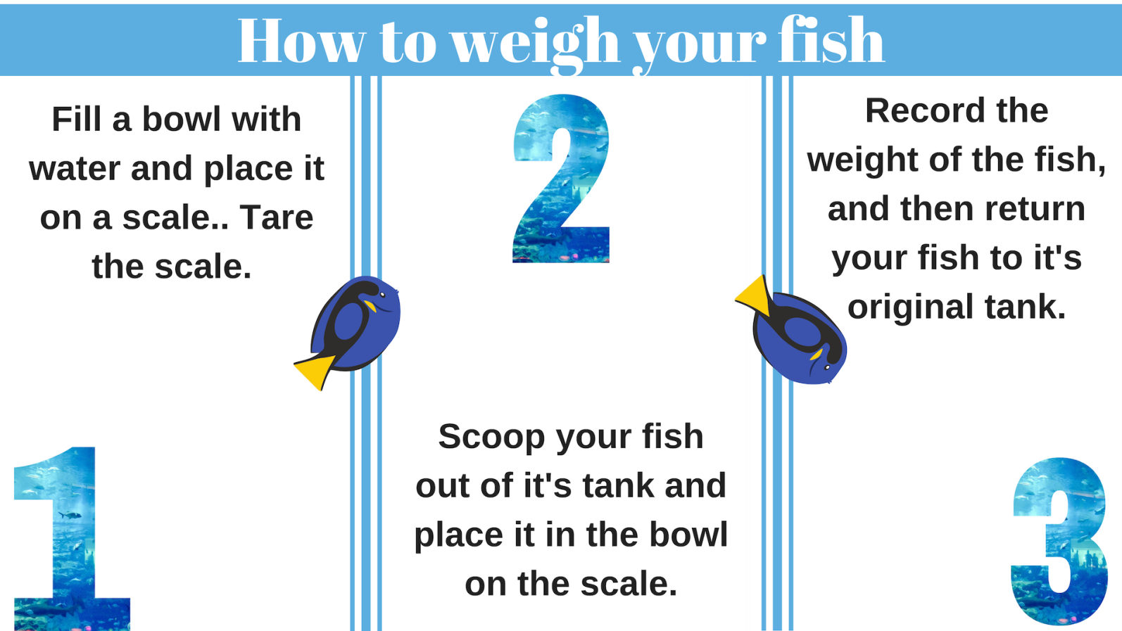One per week, take each fish out of its tank and weigh it. Record this weight, as you will use this data to monitor the fish’s growth.

*(3 marks)*

\*\***THIS IS A VERY ROUGH DRAFT. PLEASE GO THROUGH AND RESEARCH WHETHER THIS WOULD WORK WITH NIKKI. SHOULD BE OKAY FOR ETHICS THOUGH\*\***

**Data Presentation.**

Title: __________________________________________________________________________________________

|  |  |  |  |  |
| --- | --- | --- | --- | --- |
| **Week** | **Weight** | | | **Percentage increase** |
| **Trial 1** | **Trial 2** | **Average** |
| 1 |  |  |  |  |
| 2 |  |  |  |  |
| 3 |  |  |  |  |
| 4 |  |  |  |  |
| 5 |  |  |  |  |
| 6 |  |  |  |  |

*(3 marks)*

Title: __________________________________________________________________________________________

|  |  |  |  |  |
| --- | --- | --- | --- | --- |
| **Week** | **Weight** | | | **Percentage increase** |
| **Trial 1** | **Trial 2** | **Average** |
| 1 |  |  |  |  |
| 2 |  |  |  |  |
| 3 |  |  |  |  |
| 4 |  |  |  |  |
| 5 |  |  |  |  |
| 6 |  |  |  |  |

*(3 marks)*

Title: __________________________________________________________________________________________

|  |  |  |  |  |
| --- | --- | --- | --- | --- |
| **Week** | **Weight** | | | **Percentage increase** |
| **Trial 1** | **Trial 2** | **Average** |
| 1 |  |  |  |  |
| 2 |  |  |  |  |
| 3 |  |  |  |  |
| 4 |  |  |  |  |
| 5 |  |  |  |  |
| 6 |  |  |  |  |

*(3 marks)*

Graph.

Title: __________________________________________________________________________________________

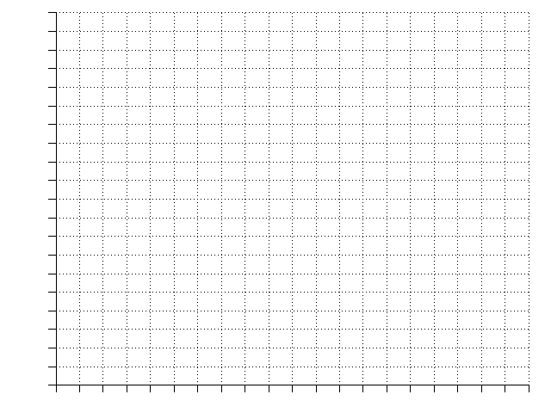*(5 marks)*

**\*Spare graph on the back page. Indicate clearly if you are going to use this\***

**Data Analysis.**

1. **Describe any trends that are evident in your results by explicitly referring to the data.**

________________________________________________________________________________________________________________________________________________________________________________________________________________________________________________________________________________________________________________________________________________________________________________________________________________________________________________________________________________________________________________________________________________________________________________________________________________________________________________________________________________________________________________________________

*(4 marks)*

The most exciting part about a scientific inquiry is that, once the investigation has been completed, you end up developing more questions than you answer.

1. **In the space below, construct one question that this data raises that we cannot answer with the information we currently have.**

________________________________________________________________________________________________________________________________________________________________________________________________________________________________________________________________________

*(1 marks)*

1. **If this experiment had aimed to determine the impact of these abiotic factors on an entire ecosystem, would it be:**
2. **Valid?**

________________________________________________________________________________________________________________________________________________________________________________________________________________________________________________________________________________________________________________________________________________________________________________________________________________________________________________________

*(3 marks)*

1. **Reliable?**

________________________________________________________________________________________________________________________________________________________________________________________________________________________________________________________________________________________________________________________________________________________________________________________________________________________________________________________

1. *marks)*
2. **In this experiment, you almost entirely removed light from one of the fish tanks. What impact would you expect this abiotic change to have on a real ecosystem?**

________________________________________________________________________________________________________________________________________________________________________________________________________________________________________________________________________________________________________________________________________________________________________________________________________________________________________________________________________________________________________________________________________________

*(3 marks)*

1. **Discuss any precautions that had to be taken to ensure this was an ethical investigation.**

________________________________________________________________________________________________________________________________________________________________________________________________________________________________________________________________________________________________________________________________________________________________________________________________________________________________________________________________________________________________________________________________________________

*(2 marks)*

1. **Write a scientific conclusion for this experiment.**

________________________________________________________________________________________________________________________________________________________________________________________________________________________________________________________________________________________________________________________________________________________________________________________________________________________________________________________________________________________________________________________________________________

*(2 marks)*